Homework #01

(a) Plot x1(t) and x1[n] in figure 1.

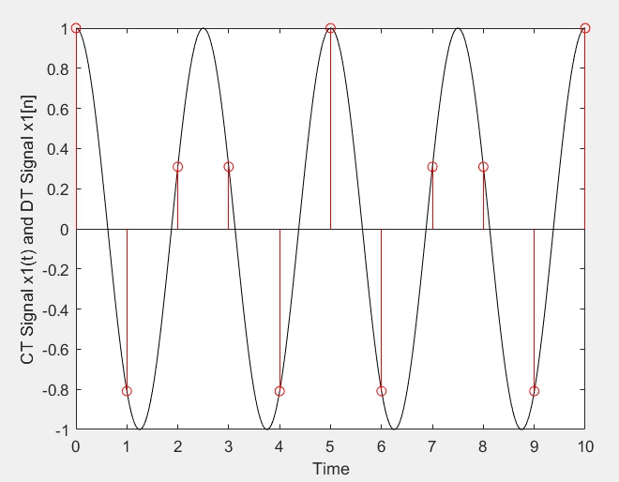

(b) Plot x2(t) and x2[n] in figure 2.

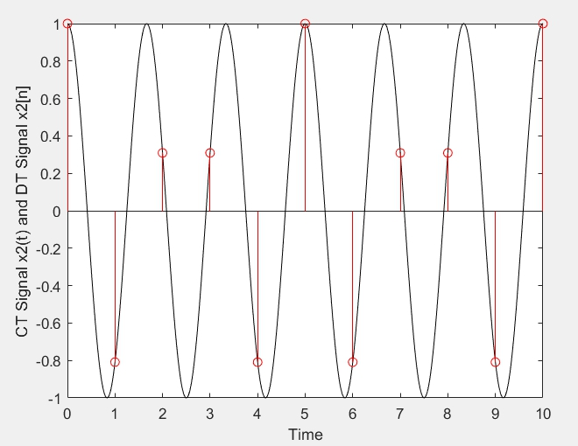

(c) Plot x3(t) and x3[n] in figure 3.

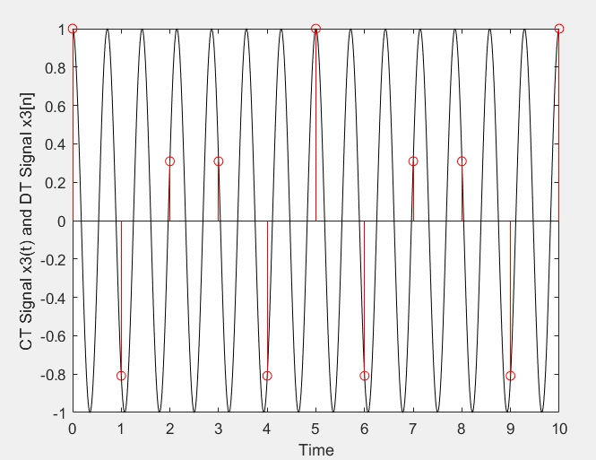

(d) Plot x4(t) and x4[n] in figure 4.

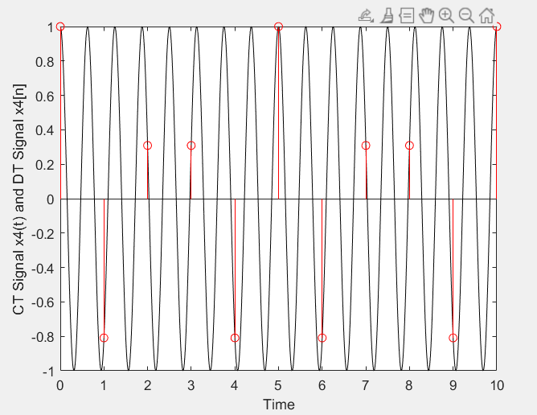

(e) Plot x1(t), x2(t), x3(t), and x4(t) in figure 5.

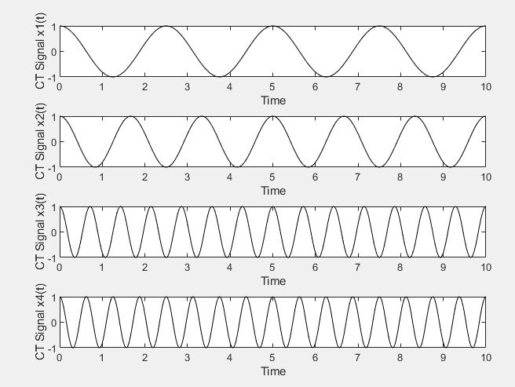

(f) Plot x1[n], x2[n], x3[n], and x4[n] in figure 6.

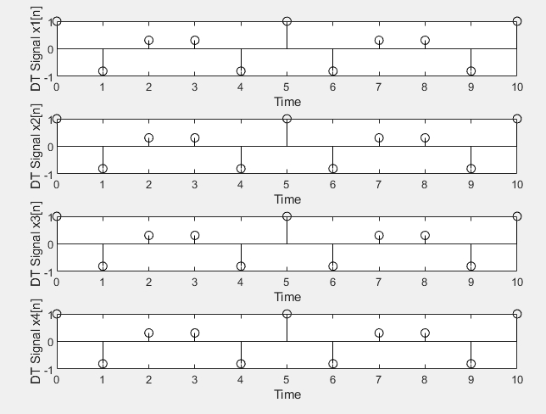

(g) Observe (e) and (f), and discuss it.

雖然在CT裡的各個訊號皆不相同，但取樣後的DT訊號是完全一樣的，由此可知，從CT訊號取樣成DT訊號不是一對一的轉換。